**How to Unload Dirt/Gravel from a Pickup with help of Bed Cargo Unloader**

At the point when pickup trucks are utilized in finishing occupations, it includes a ton of rock, earth, and wooden logs pulling. Albeit the truck bed works really hard of shipping them however turns into agony when it's an ideal opportunity to dump. Basically, in arranging and other field business-related positions the effectiveness of the pickup truck is in its capacity to rapidly pull material and dump as an afterthought quicker. Learn more about the [best truck bed cargo unloader](https://myoffroadgear.com/best-truck-bed-cargo-unloader/) by following the article.

On the off chance that you are in one of these organizations, you realize you need to take care of that truck bed; it's not effective to physically dump or dump all that material quicker. You would have truly profited on the off chance that you improve your truck bed's material unloading capacity. You can't generally recruit a Class 5 dump truck and an ensured driver, each an ideal opportunity to ship rock or earth. Anyway, how would you be able to respond?

Here are a couple of choices that will empower you to altogether expand your truck's unloading capacity:

1. Replace the current truck bed with an unloading bed.
2. Convert the current pickup bed into a dump.
3. Install an unloading bed on top of the pickup bed.

**Utilizing Dump Bed Inserts**

[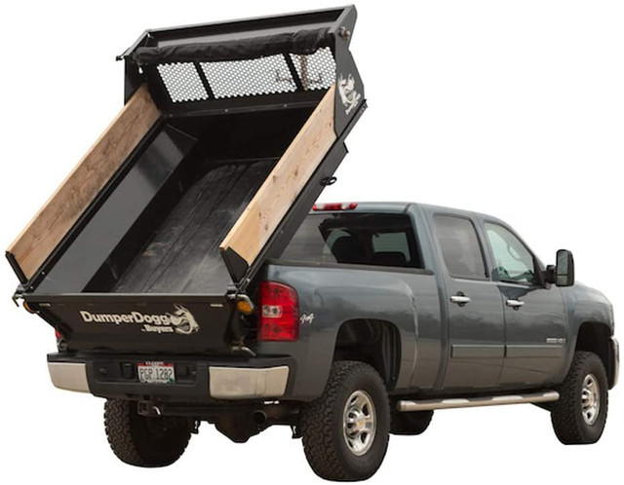](https://myoffroadgear.com/best-truck-bed-cargo-unloader/)

This is by a long shot the least demanding approach to transform your pickup bed into a dump bed. You will discover embeds for both short and long-bed pickups. Also, it tends to be moved to another pickup, in the event that you buy another one. It is essentially a second bed unit that lays on top of the current bed. The establishment doesn't need a lot of alteration to the truck and obviously, the bed doesn't need to be eliminated. Your truck's fuel fill cap and filler hose stay in their unique area. Then again, it adds a ton of weight to the bed, spending a great deal of your bed's payload limit.

**Secret Hoist Kit**

On the off chance that you don't need your [pickup truck](https://www.cars.com/research/truck/) to appear as though a dump truck yet at the same time need the simple unloading ability, you could settle on a crane change. It keeps your pickup appears to be identical however gets an additional ability under. The vast majority of the packs are imperceptible until you raise the bed. This is an incredible method to utilize your truck bed full [payload limit](https://www.readingbody.com/calculating-your-trucks-maximum-payload-and-towing-capacity/) yet ready to dump without utilizing embeds. Furthermore, it keeps your truck's unique plan.

Then again, it has a disadvantage. The establishment requires some work done, for example, changes to the fuel fill area, hitch parts, and so on Introducing lift units require migrating spare tire well zone, including a lot another adjustment.

**Full Conversion**

A full transformation implies you need to totally eliminate the stock bed and supplant it with a dump bed from the secondary selling. This is one of the adjustments numerous frame taxi proprietors do. The full transformation will empower you to repurpose a current pickup, expand the payload limit and use it dedicatedly for pulling and unloading as it were.

Then again, your truck won't appear to be identical. Also, you can't simply invert it back to its unique plan as you again need to make a lot of alterations.